Relationship Photo Timeline August 2025 to August 2026
Scott Phillip Warren and Kristina Aleksandrova Warren Client reference WaKr-2631-801-3
These photographs show family events, travel and ordinary time together. The August 2025 photographs provide brief context immediately before the Subclass 820 grant on 24 September 2025; the remaining photographs cover the period after grant.
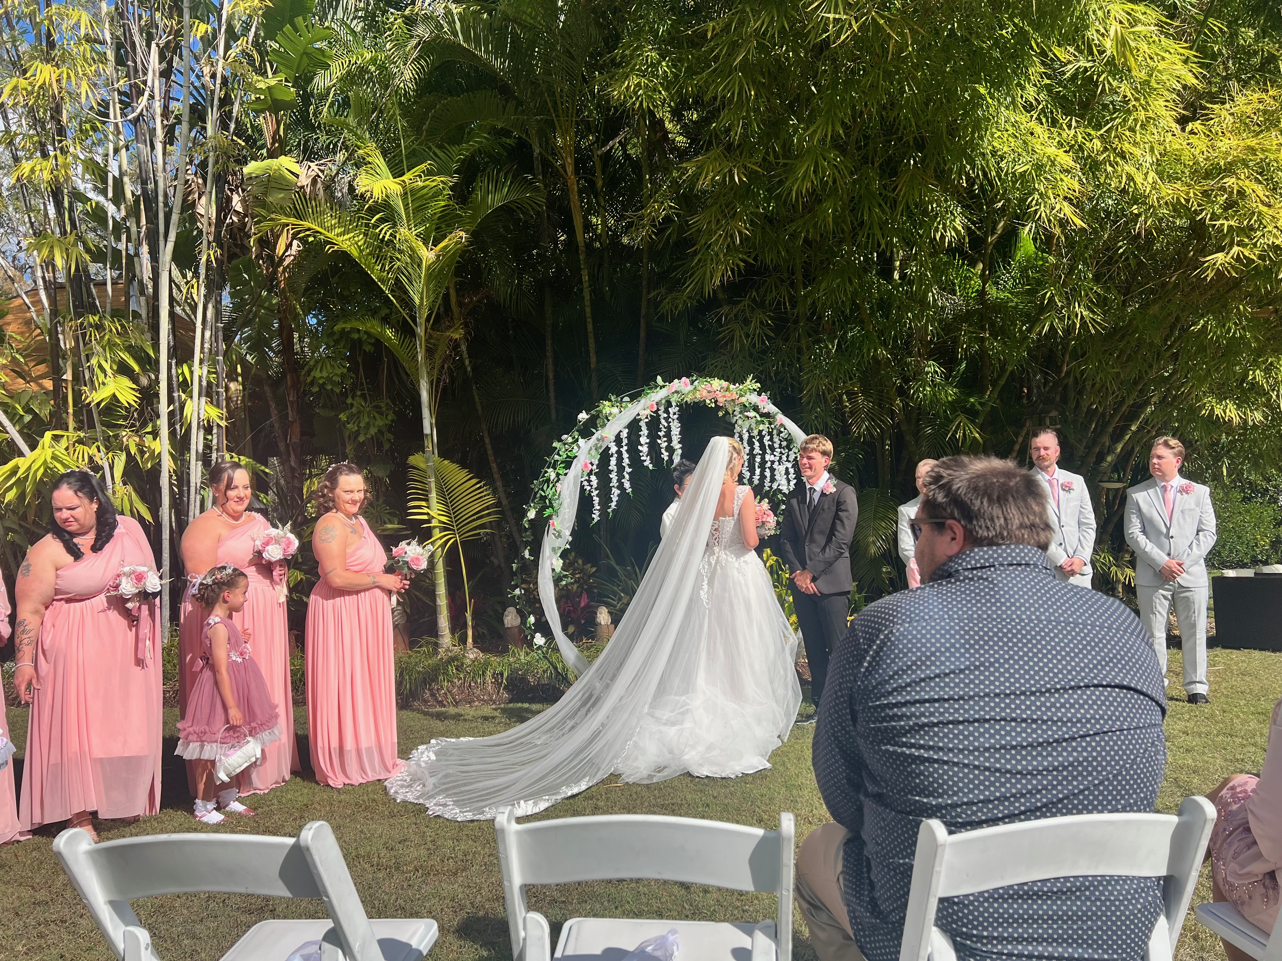
15 August 2025 Buccan, Queensland
Friends' wedding ceremony attended by Scott and Kristina together.

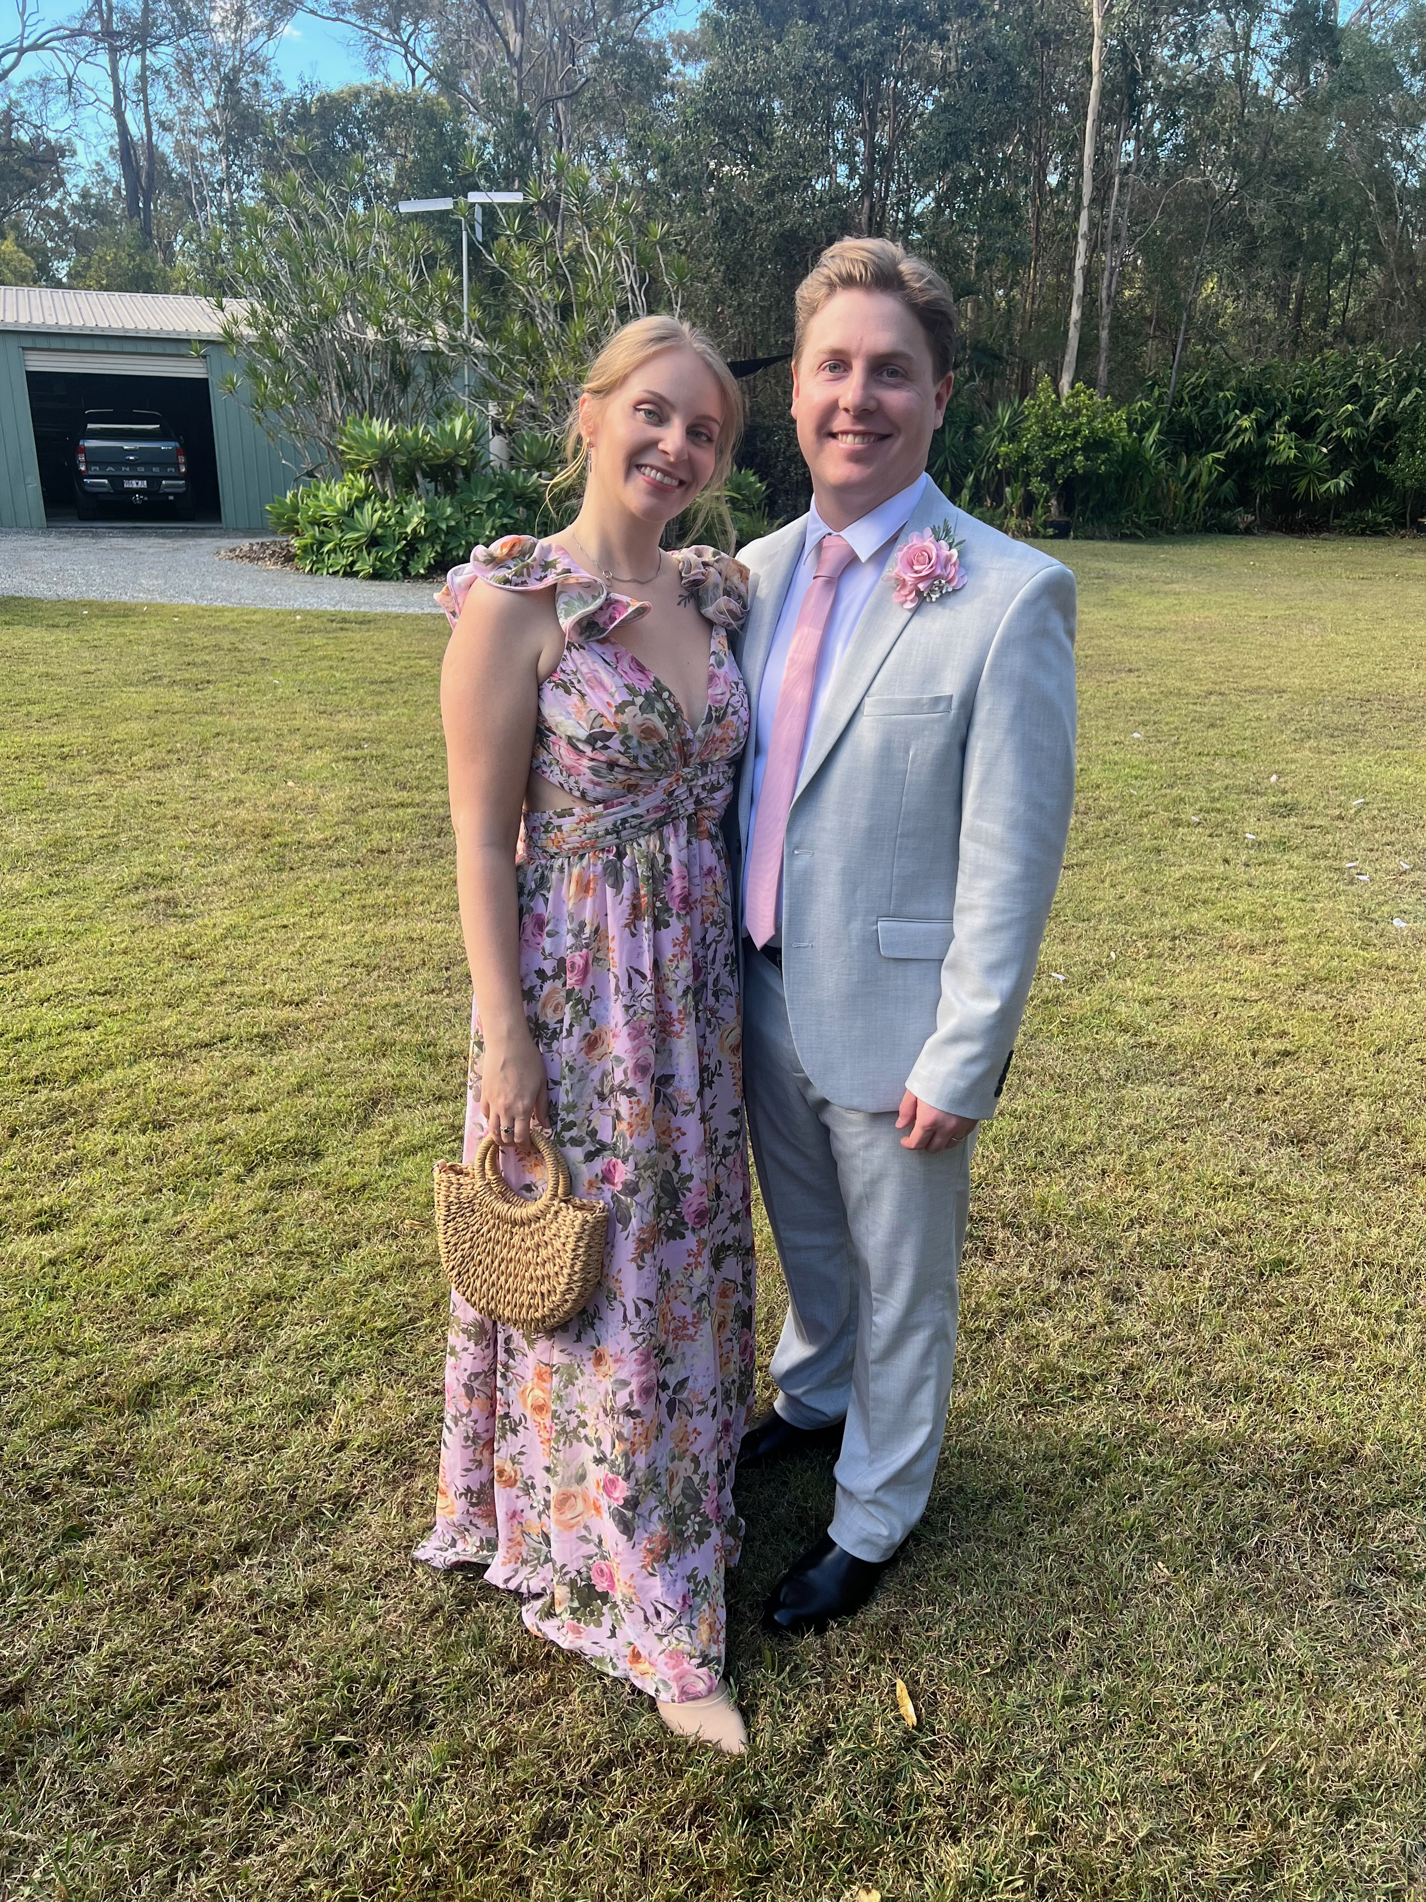
15 August 2025 Buccan, Queensland
Scott and Kristina together at their friends' wedding.


29 August 2025 North Wall Beach, New South Wales
Scott and Kristina on a walk together at the beach.

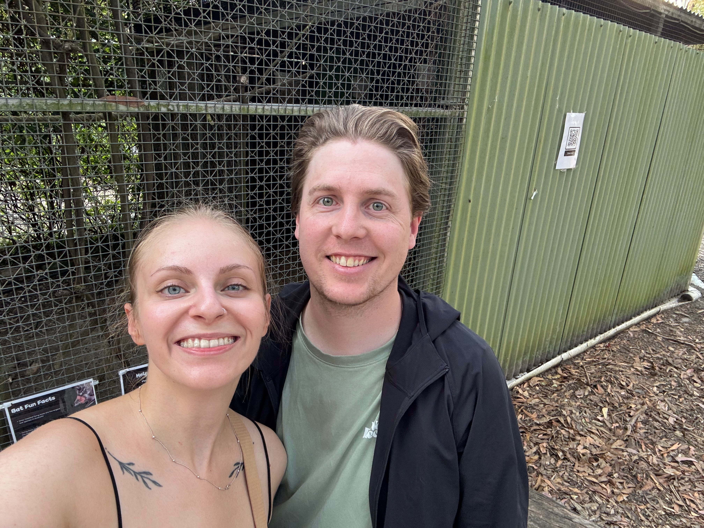
8 November 2025 Calga, New South Wales
Scott and Kristina together during a day trip.

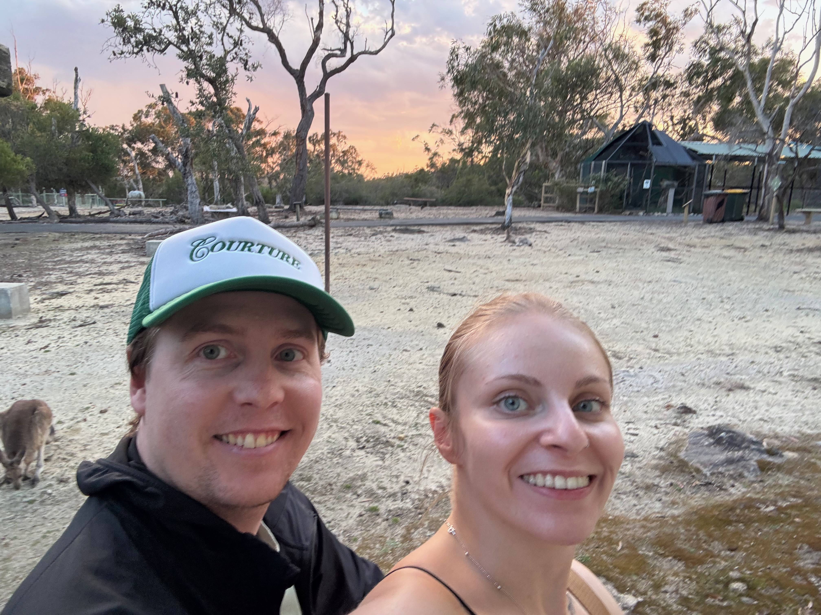
8 November 2025 Calga, New South Wales
Scott and Kristina watching kangaroos at sunset during their day trip.

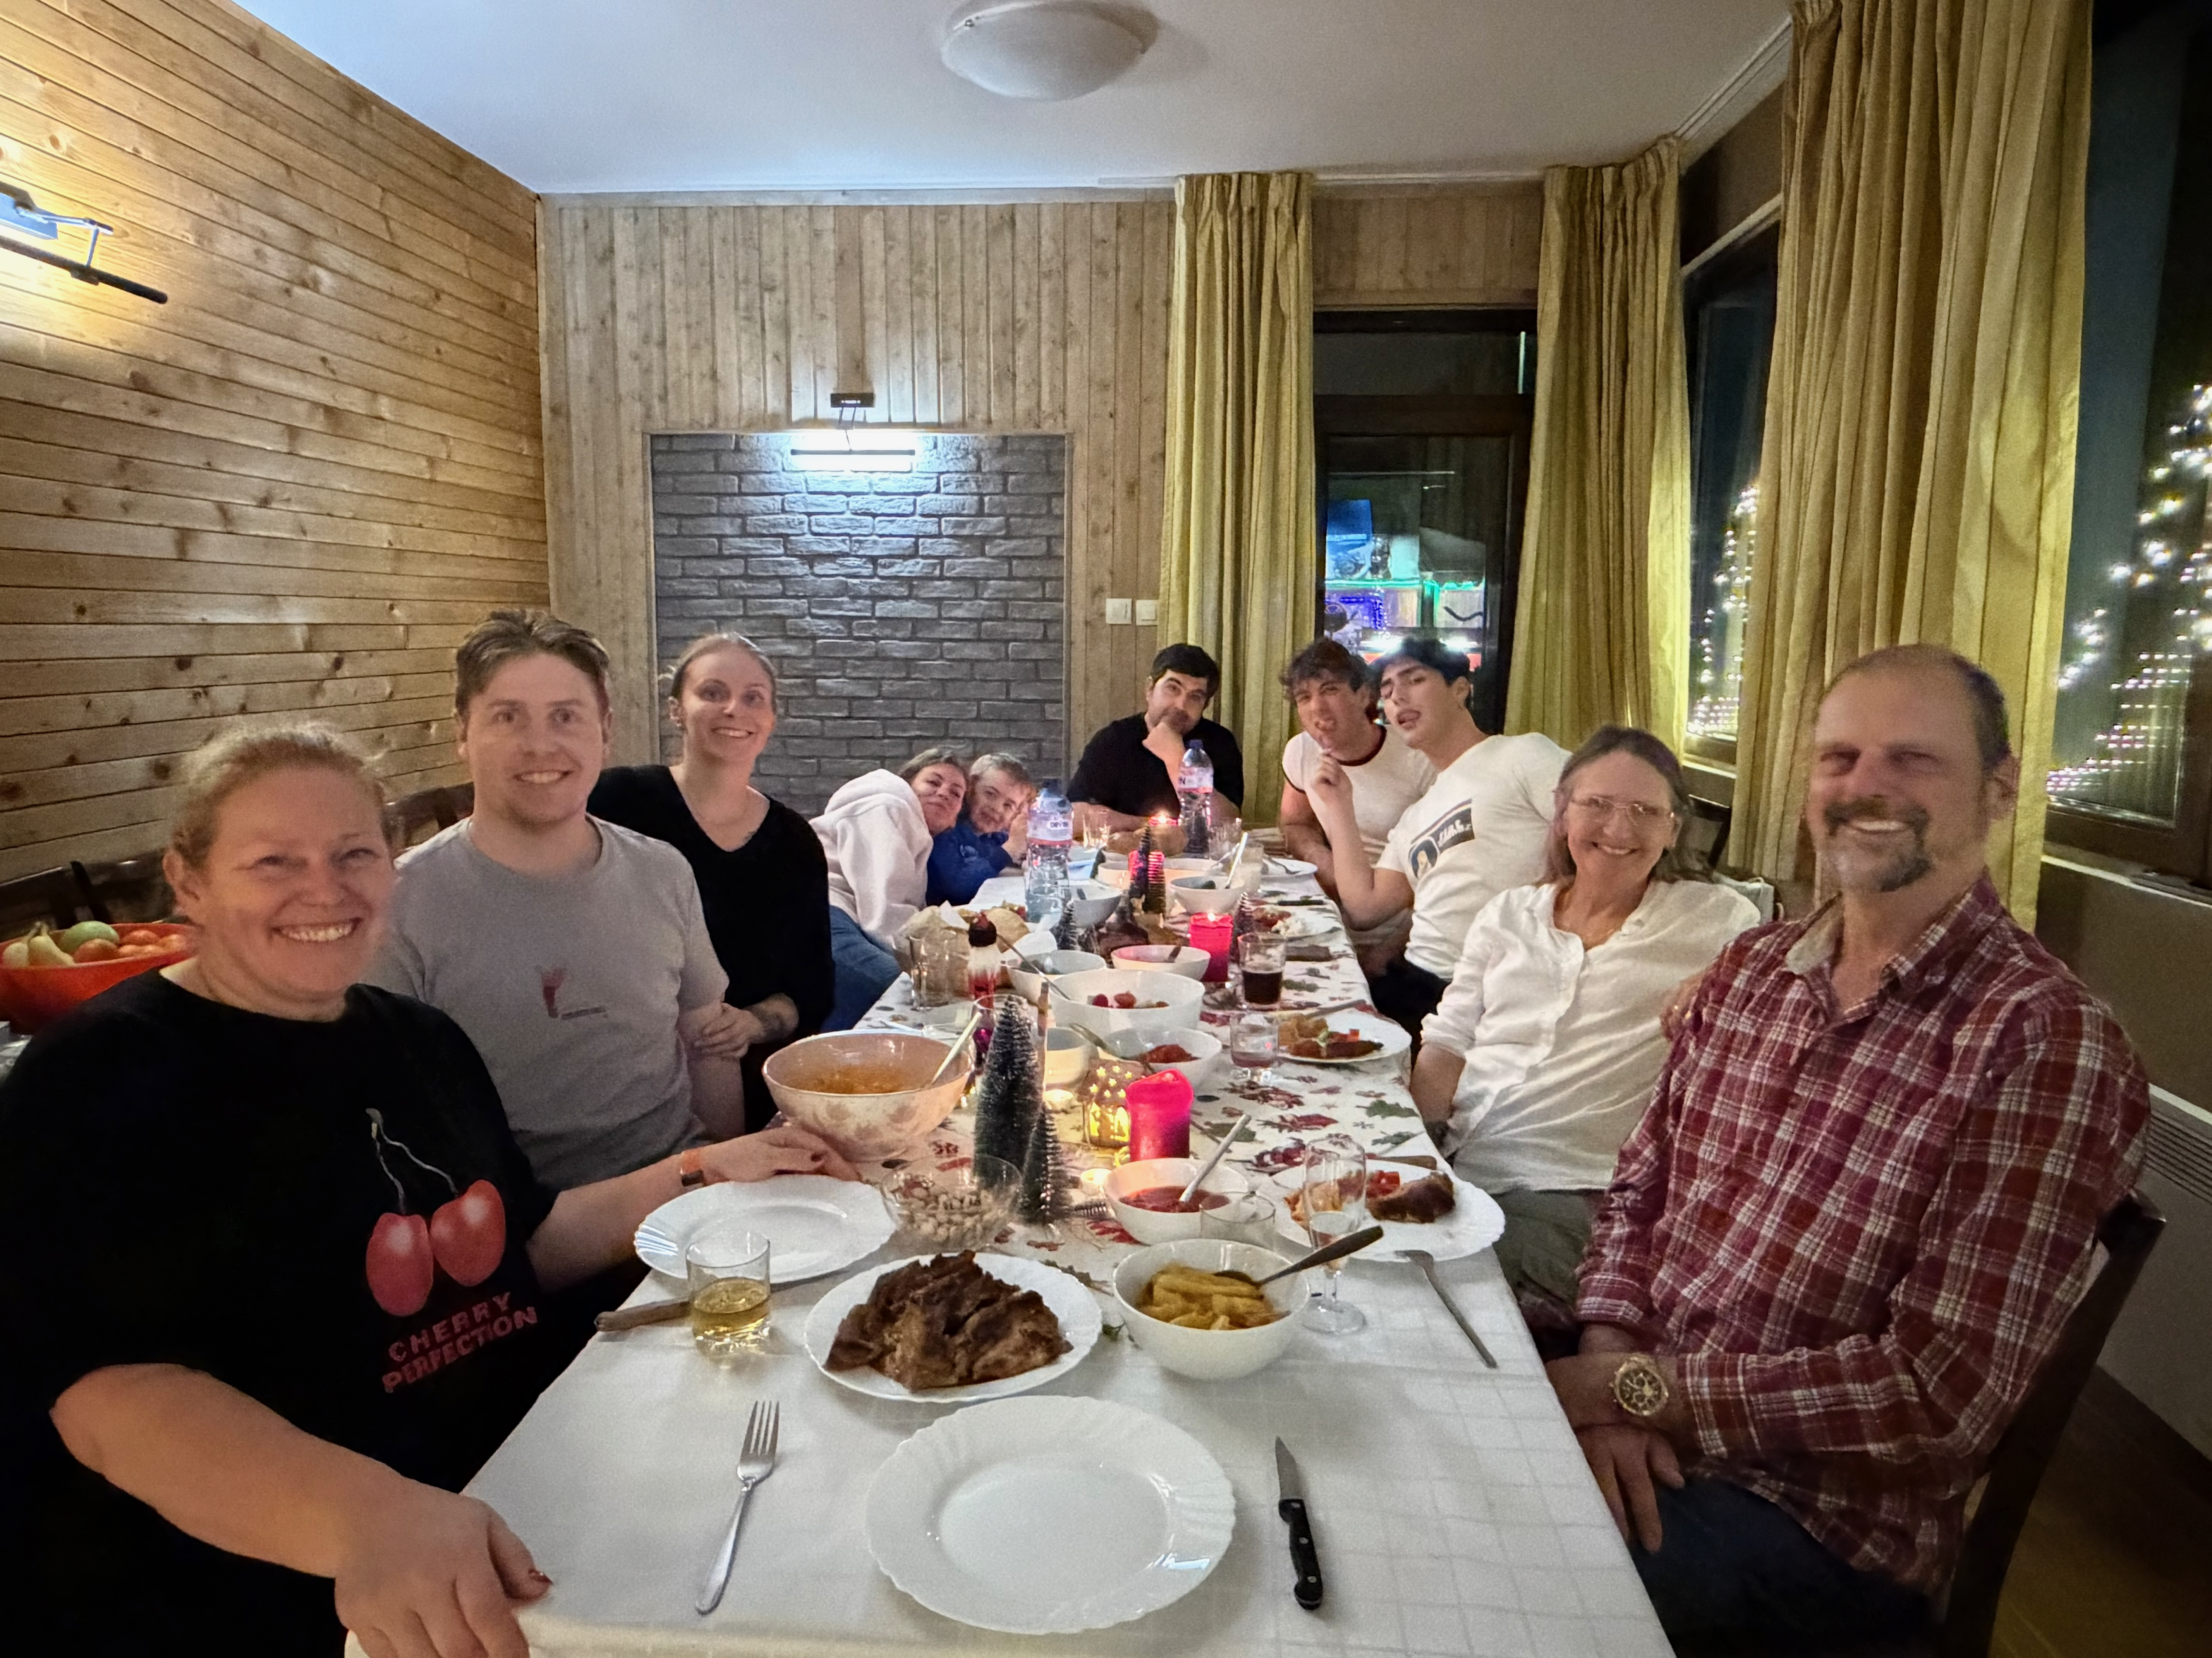
23 December 2025 Borovets, Bulgaria
Scott and Kristina celebrating Christmas with both sides of their family.

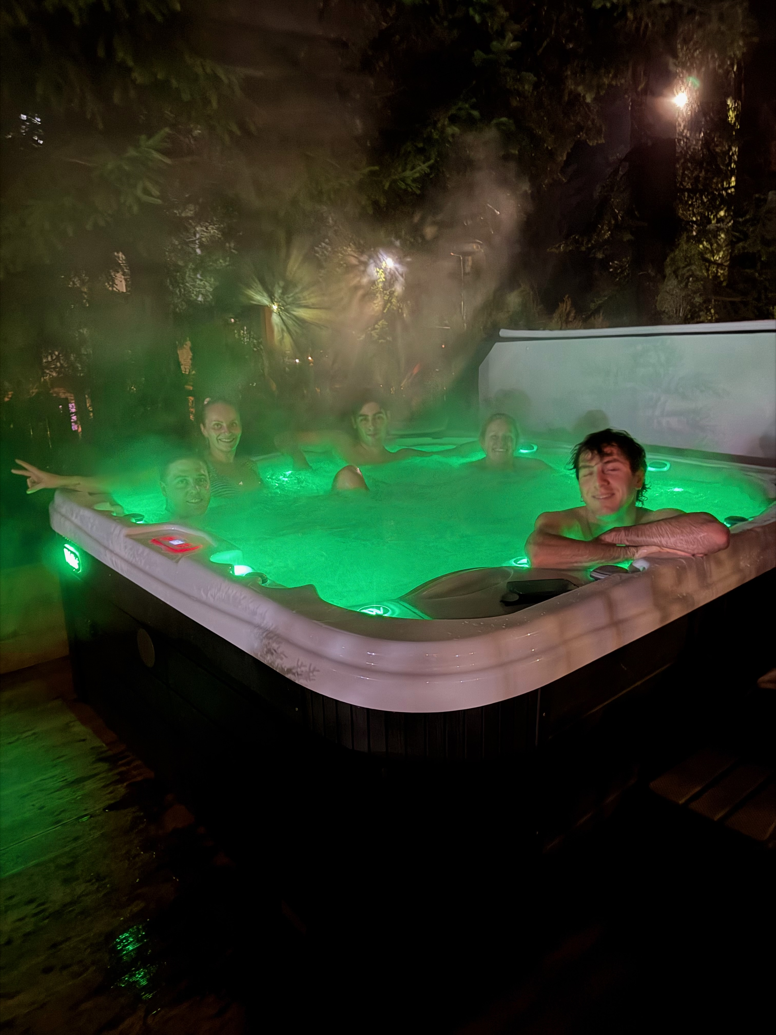
23 December 2025 Borovets, Bulgaria
Relaxing together in the chalet hot tub during the family Christmas trip.

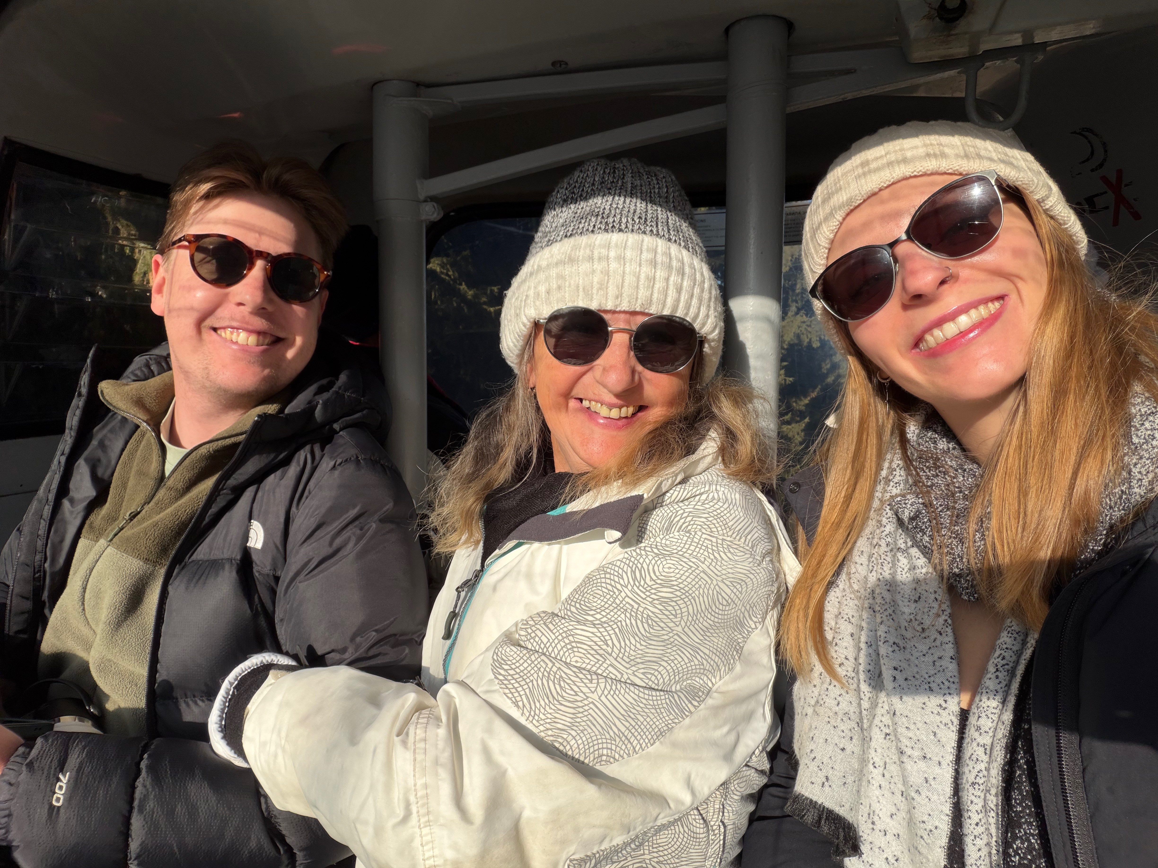
23 December 2025 Borovets, Bulgaria
Scott and Kristina with family on the ski lift.

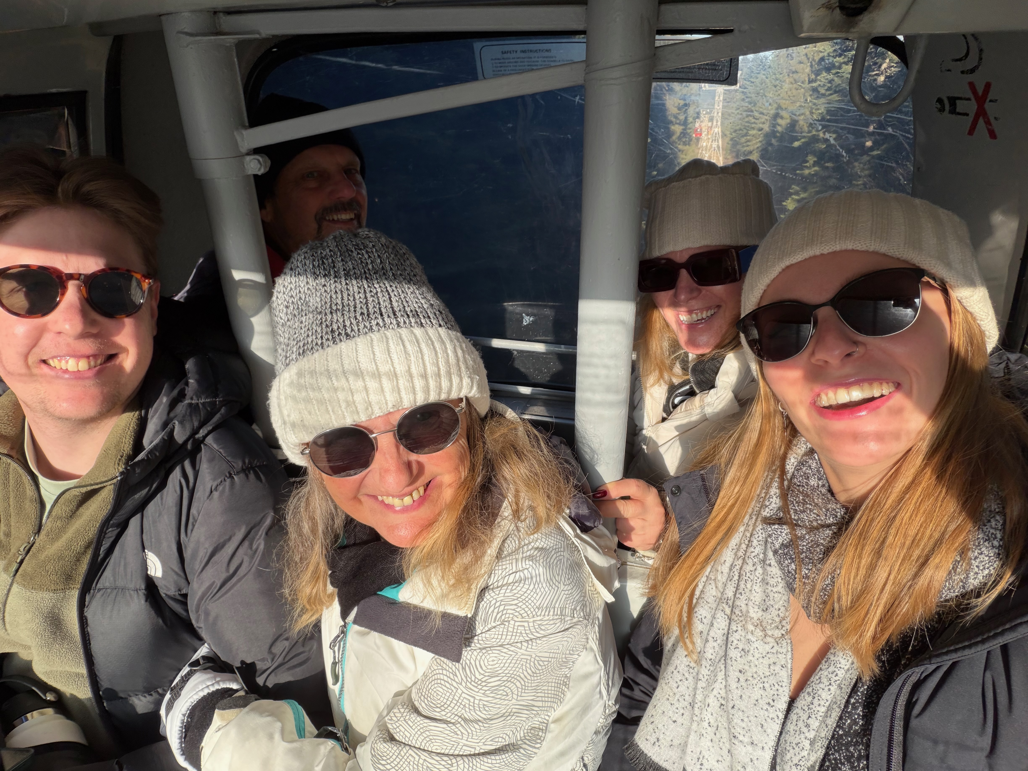
23 December 2025 Borovets, Bulgaria
Scott and Kristina with family on the ski lift during their Christmas holiday.

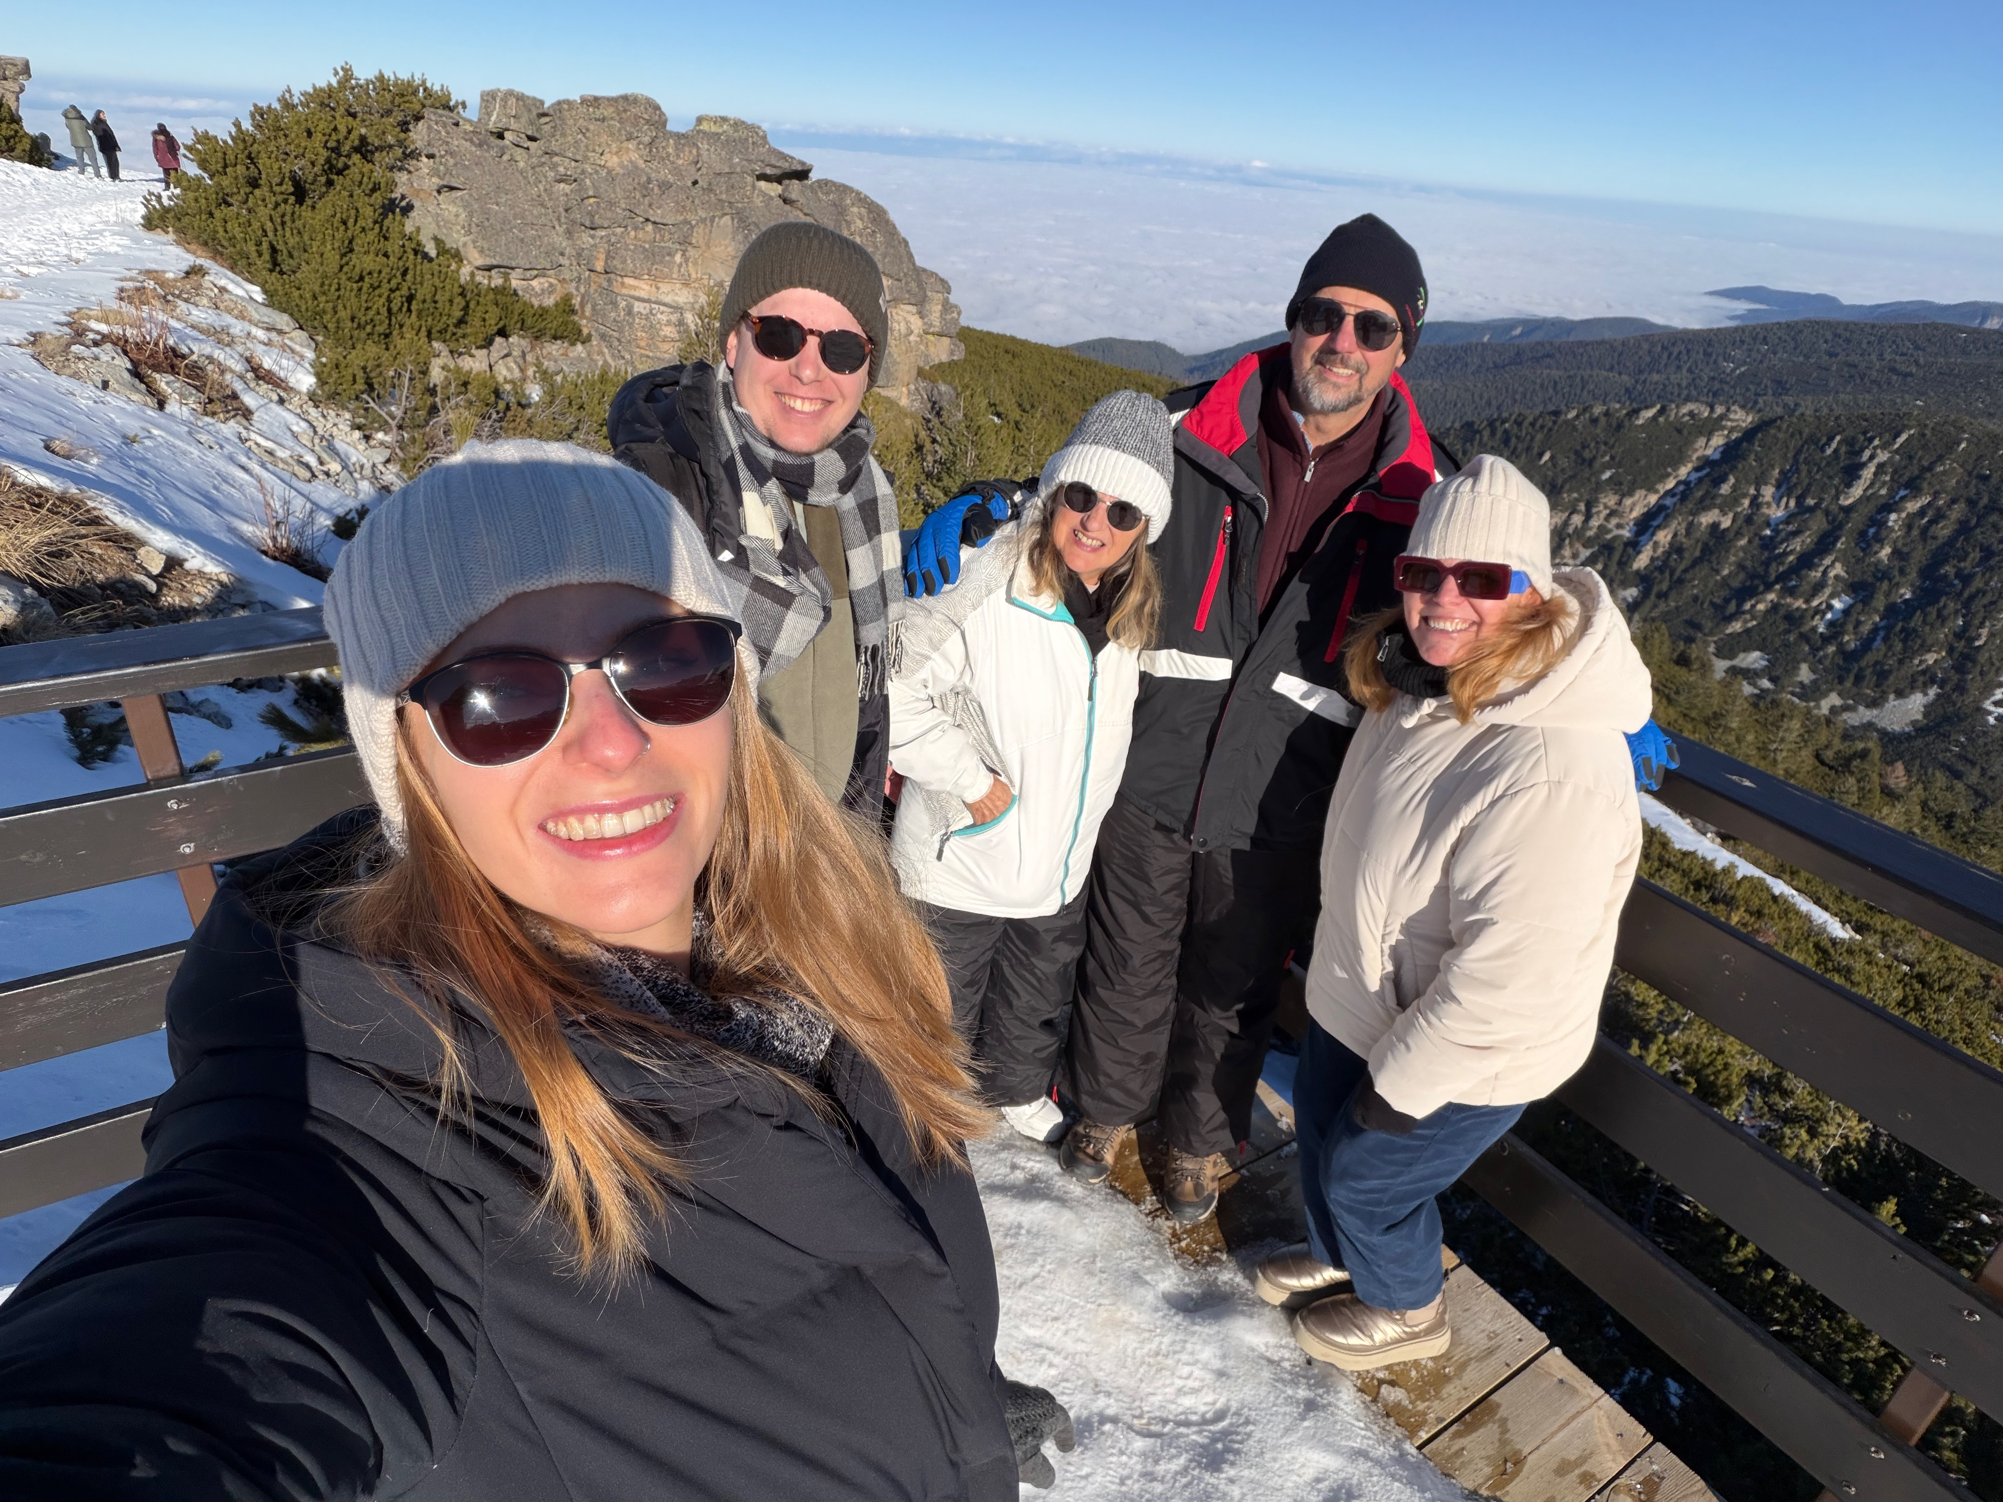
23 December 2025 Borovets, Bulgaria
Scott, Kristina and family together in the snow.

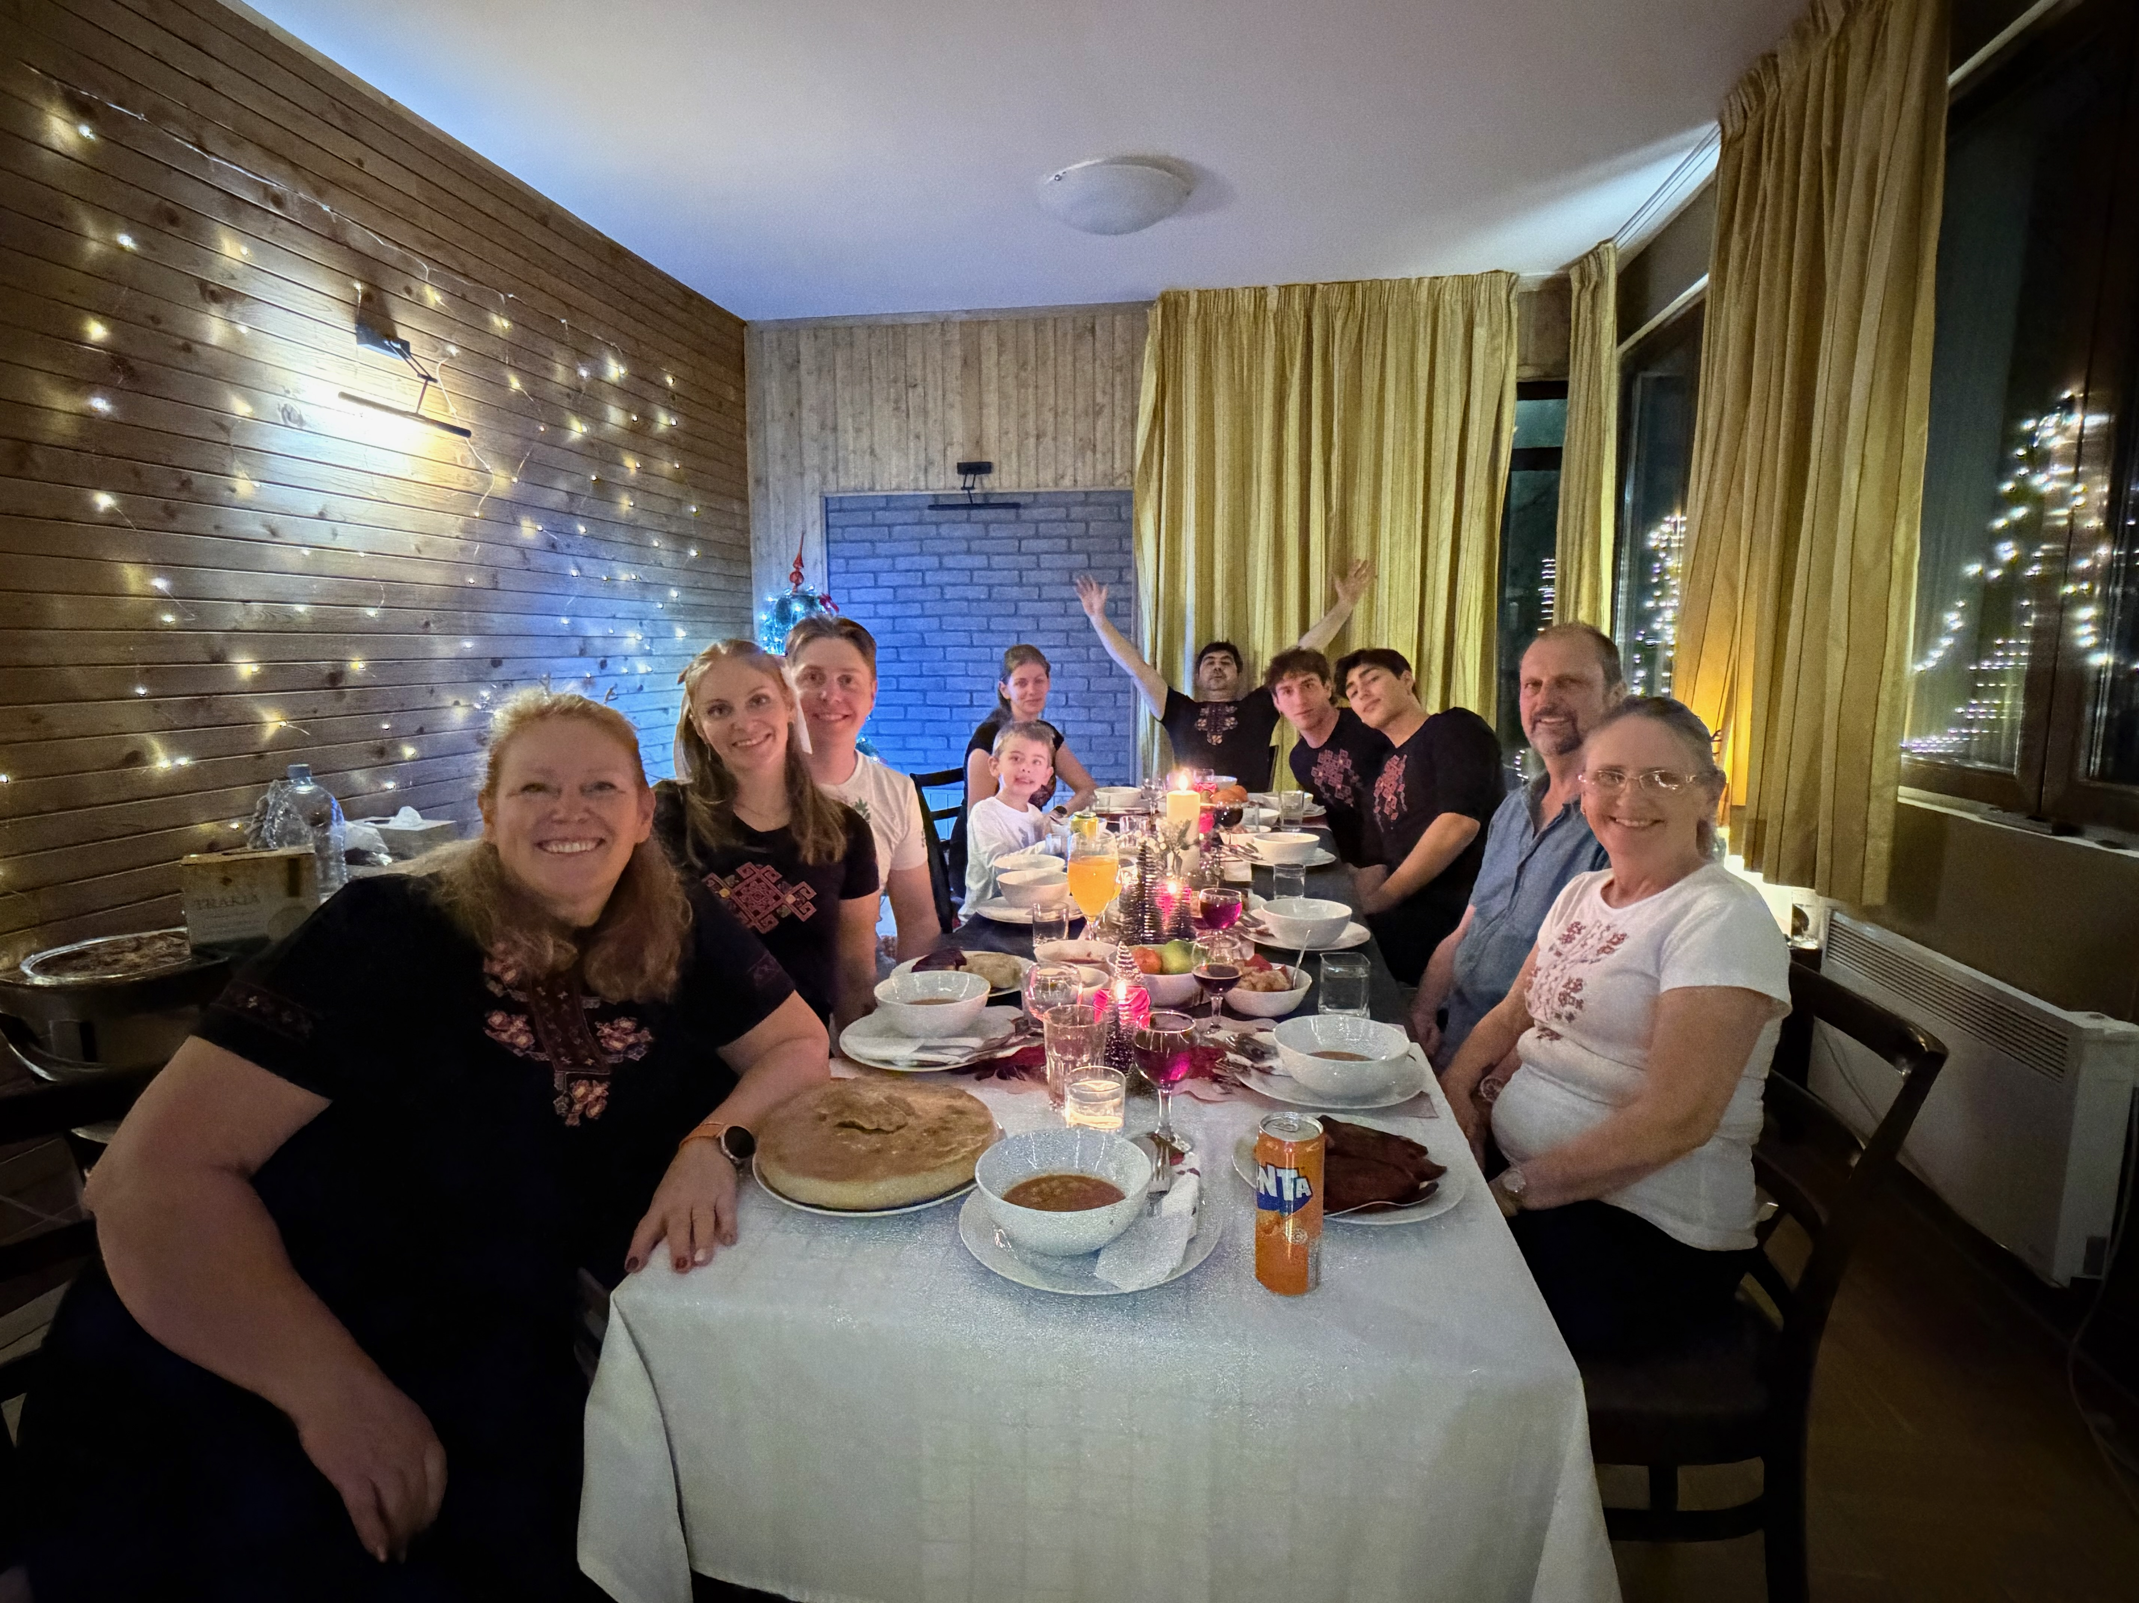
25 December 2025 Borovets, Bulgaria
Christmas Day meal with Scott, Kristina and family from both sides.


28 December 2025 Sofia, Bulgaria
Scott and Kristina sharing a family dinner during their Christmas visit.


4 January 2026 Ovoshtnik, Bulgaria
Scott and Kristina together during their holiday in Bulgaria.


28 February 2026 Engie Stadium, Sydney
Scott and Kristina attending a concert together.


11 June 2026 Bulgaria
Scott and Kristina sharing a meal with family and friends during their June visit.

16 June 2026 Sofia, Bulgaria
Scott and Kristina with family before returning to Australia.

16 June 2026 Sofia, Bulgaria
Scott and Kristina spending time with family during the June visit.

19 June 2026 Location not recorded
Scott and Kristina together on a day out after returning to Australia.

11 July 2026 Woolgoolga, New South Wales
Scott and Kristina on a coastal walk together.

11 July 2026 Woolgoolga, New South Wales
Scott and Kristina together on the Woolgoolga coast.

19 July 2026 Location not recorded
Scott and Kristina walking with friends and their dog.

2 August 2026 Location not recorded
Scott and Kristina on a sailing outing with friends.

11 August 2026 Location not recorded
Scott and Kristina spending time with friends.

29 August 2026 Location not recorded
Scott and Kristina together during a day out.

